HW7-B: Customer Development-Part 2 (2 p)
Fall 2025
Team Number and Name:
List all students who actively worked on this Assignment:
- Name: Ritujit Chaudhury
- Name: Rhea Roy
- Name: Shamsheer Hussain
- Name: Prakriti Mishra
- Name: Nehal Vaiti

Summary of Findings (1 p)
Team: Group 1 | Interviews: 25 (15 Buyers, 10 Sellers) | October 2025

Executive Summary
Customer interviews validate that ingredient sourcing for cultural cooking represents a significant recurring pain point with strong market opportunity. 100% of buyers reported frustration cooking cultural dishes, spending 1-2 hours per grocery trip searching for ingredients. Social friction in repeatedly asking friends for help creates unsustainable knowledge-sharing burden. Both buyers and sellers express clear willingness to participate in platform solution.

Buyer Insights
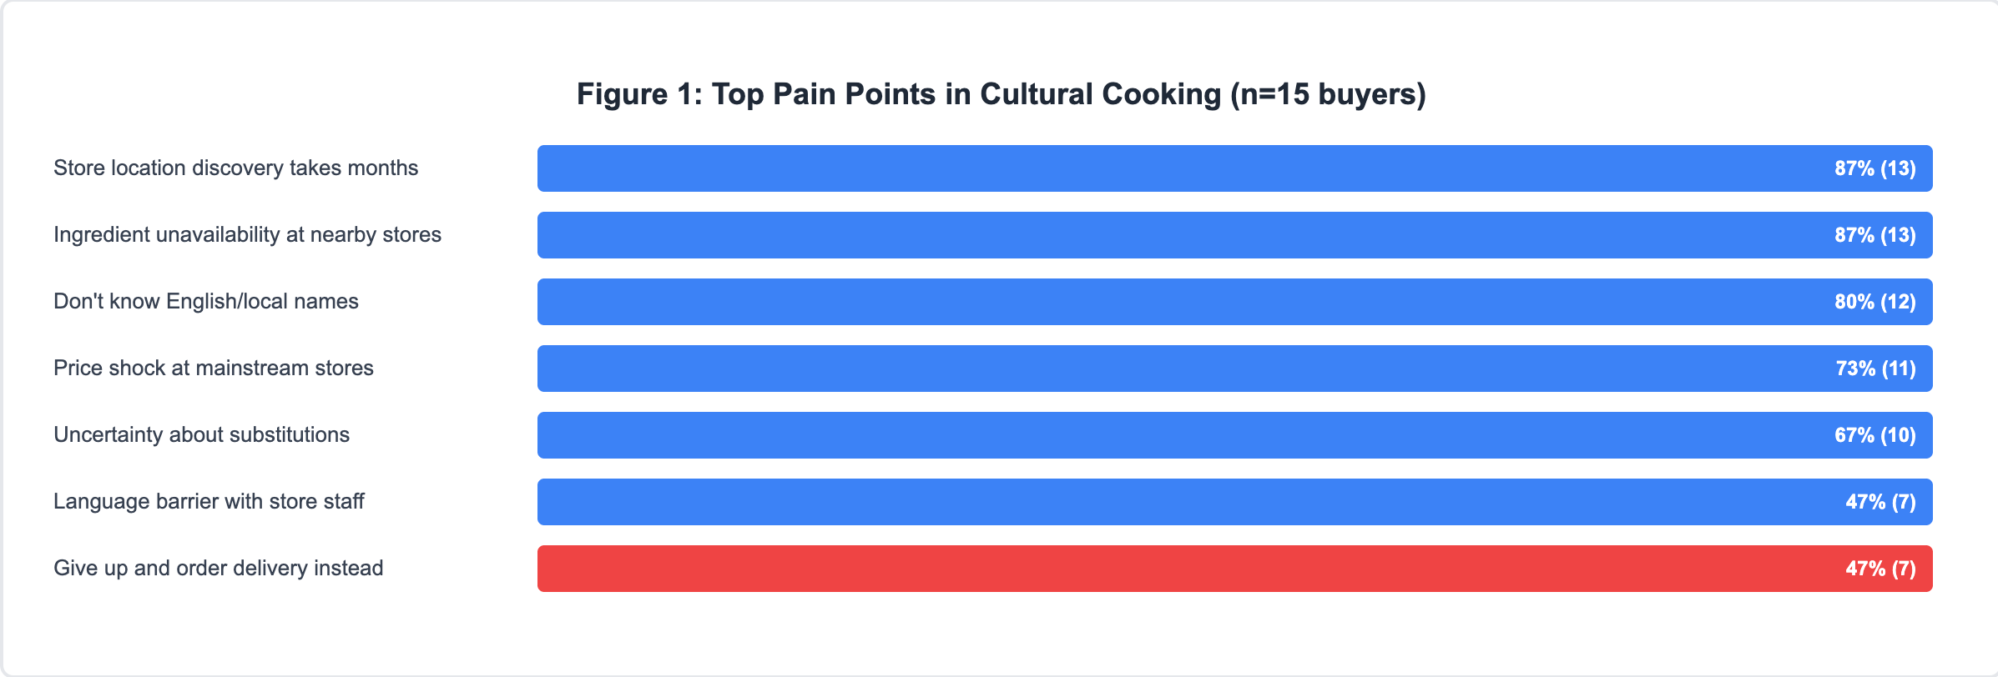
Ingredient Discovery Timeline: 87% (13/15) took 1-3 months to discover ethnic grocery stores (Patel Brothers, Apna Bazar, India Quality Mart). During this period, students gave up on cultural cooking or wasted money on incorrect substitutes. See Figure 1.

Social Friction Validated: 80% (12/15) feel "awkward," "embarrassed," or "burdensome" asking friends repeatedly. Key quotes: "I've asked her three or four times...each time I feel more awkward" | "Sometimes I'll just not cook instead of texting her again" | "I don't want to be that person always asking basic questions." See Figure 2.

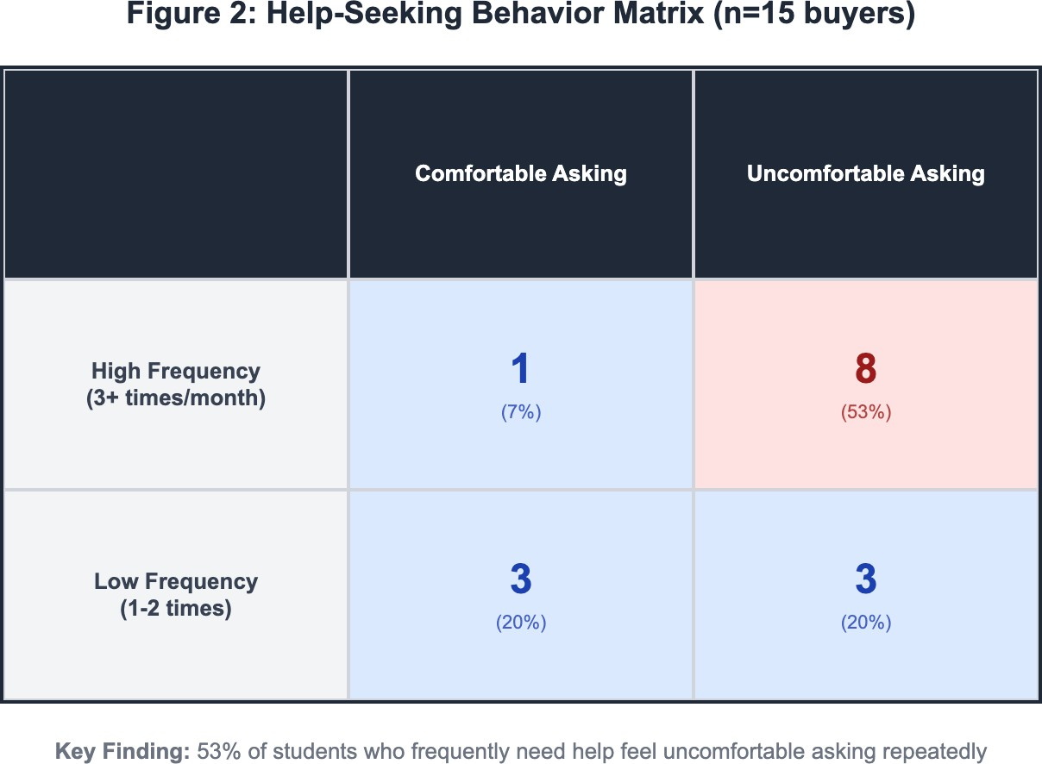
Current Workarounds Fail: YouTube (53% usage, not Boston-specific), family calls (40%, time zones/not local), Google/Reddit (67%, generic), asking friends (80%, highest friction), giving up (47%, order delivery). Most effective solution has worst scalability. See Figure 3.
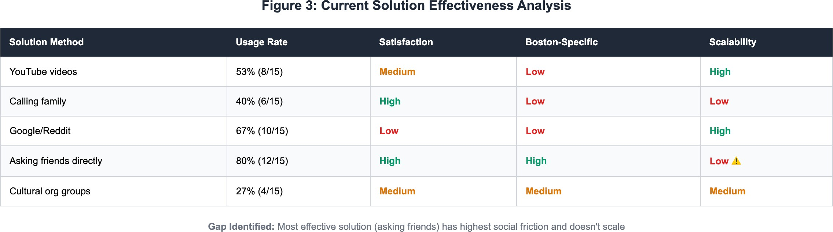

Financial Impact: Students waste $40-200 on wrong ingredients, duplicate purchases, premium prices at mainstream stores ($8 paneer at Whole Foods vs. cheaper at Patel Brothers), and delivery orders. See Figure 4.

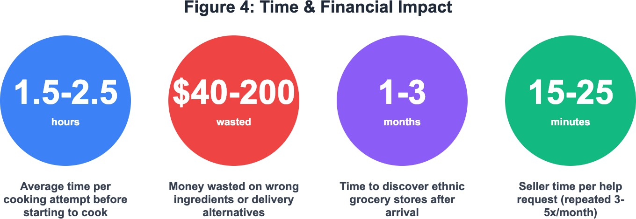

Seller Insights:

Willing but Constrained: 90% (9/10) cite time and repetitiveness as barriers. All want to help but one-on-one model doesn't scale. Quote: "I've explained where to find hing six times...same 10-minute explanation each time." See Figure 5.

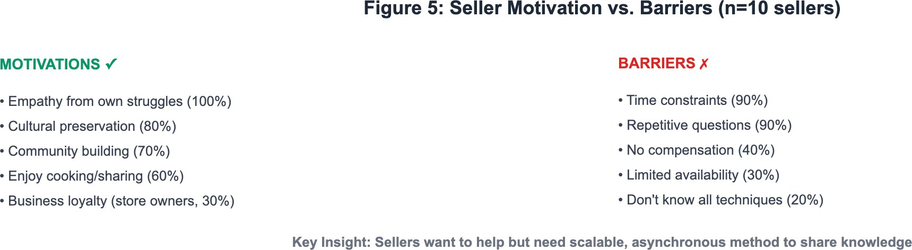

Knowledge Acquisition: Sellers spent 1-6 months learning: store locations, price comparisons, seasonal availability, American substitutes (Greek yogurt for dahi), brand recommendations.
Currently shared inefficiently through individual conversations.

Strong Motivation: Empathy (remembering own struggles), cultural preservation, community building. Store owners see business opportunity in systematic knowledge sharing for customer loyalty.

Segment Analysis:
Beginners (n=6): Highest abandonment (83% gave up and ordered delivery). Don't know English ingredient names, waste most money. Most acute need for basic guidance.
Dietary Restrictions (n=3): Heightened anxiety, limited substitution options. Vegetarian/halal requirements make accuracy critical. Travel farther for correct ingredients.
Cultural Sharing (n=6): Pressure representing culture to Americans. Fear of embarrassment if food doesn't taste authentic. Highest emotional stakes.

Opportunity Validation:
Demand Signals: Universal problem (15/15 affected) | Recurring need (2-4x/month) | Willingness to pay evidenced by current waste | Supply-side validation (sellers willing to contribute if systematized)
Competitive Gap: No solution provides Boston-specific, culturally authentic, peer-to-peer guidance. All current solutions fail on 2+ dimensions: local relevance, cultural authenticity, or social scalability.
Bottom Line: Strong validation for ChowPal. Social friction confirmed. Time/money waste plus repetitive burden creates compelling platform case.

Appendix 1: Notes from Interviews (1 p) Team member #1 Ritujit:
BUYER RESPONSES

Arpita (Vegetarian, Dietary Restrictions) Age: 23 Place: House (Roommate)

Q1: Walk me through the last time you wanted to cook a dish from home but couldn't find the right ingredients. What specific challenges did you encounter and how did you try to solve them?
"Oh my god, just last week actually. I wanted to make paneer tikka because I was craving it so badly. I went to Stop & Shop thinking they'd have paneer in the cheese section, but nothing.
Then I tried Whole Foods, and they had some paneer but it was $8 for this tiny pack, which is insane because back home it's so cheap. I ended up spending like an hour going between stores. I also needed kasuri methi, which is dried fenugreek leaves, and I had no idea where to even start looking for that. I tried asking someone at Whole Foods and they just looked confused.
Eventually I just ordered DoorDash from an Indian restaurant because I was so frustrated and hungry. The whole thing took 2 hours of my Saturday."

Q2: When you're grocery shopping for cultural ingredients, what thoughts go through your mind as you're walking through the aisles, and how do you currently decide what to buy when you're unsure about substitutions?
"Honestly, I feel really anxious. Like I'm standing there looking at all these spices with English names I don't recognize, and I'm thinking 'Is this the same thing or am I going to mess up the entire dish?' For vegetarian cooking, it matters so much because we use specific ingredients for protein and flavor. Like ghee versus regular butter makes a huge difference, but the store only has clarified butter and I'm not sure if it's the same. I usually just Google on my phone while standing in the aisle, which is embarrassing when other people are waiting. Sometimes I'll text my roommate who's also Indian, but I feel bad bothering her every single time I'm at the store. So I end up just guessing based on the picture on the package or buying both options to be safe, which wastes money."

Q3: Tell me about a time when you asked a friend or classmate for cooking or ingredient advice. What was that experience like and how did you feel about reaching out for help?
"Last month my classmate Priya helped me find this Indian grocery store in Malden that I didn't even know existed. She was super nice about it and even sent me pictures of the aisles and told me which brands to buy. But here's the thing - I've already asked her like three or four times about different ingredients, and each time I feel more awkward. Like, she has her own life and her own studies. I don't want to be that person who's always asking for help. Sometimes I'll just not cook the dish instead of texting her again because I feel like I'm being annoying. It's weird because if it was a one-time thing I wouldn't care, but needing help repeatedly makes me feel incompetent."

Omer (New to Cooking, Learning) Age: 28 Place: Snell Library

Q1: Walk me through the last time you wanted to cook a dish from home but couldn't find the right ingredients. What specific challenges did you encounter and how did you try to solve them?
"Two weeks ago I tried to make kofta, which is like these meat balls in curry. My mom sent me her recipe but half the spices she listed, I don't even know what they're called in English. Like what is 'garam masala' in American stores? Is it the same as curry powder? I went to Target first because it's close to my apartment, but they had like maybe five Indian spices total. Then I tried Trader Joe's and same problem. I ended up in this Middle Eastern store in Allston that my friend told me about, but even there I was just staring at spices trying to match them to my mom's WhatsApp messages. I bought like six different things hoping one of them was right. When I finally cooked it, the taste was completely off and I wasted $40 on groceries. Haven't tried cooking anything from home since then."

Q2: When you're grocery shopping for cultural ingredients, what thoughts go through your mind as you're walking through the aisles, and how do you currently decide what to buy when you're unsure about substitutions?
"I'm basically just stressed the whole time. I'm thinking 'Am I in the right section? Do American grocery stores even have this? Should I just give up and make pasta instead?' The hardest part is I don't know if I'm looking for something that doesn't exist here or if I'm just in the wrong store. Like, I spent 20 minutes looking for tahini once before realizing it's not in the spice aisle, it's near the peanut butter. That's not intuitive at all. When I'm unsure about substitutions, I usually just pick whatever looks closest or has similar packaging to what I've seen in pictures online.
Sometimes I'll call my mom on FaceTime and show her the options, but the time difference makes that hard. Honestly, most of the time I just end up buying nothing and ordering Chipotle."

Q3: Tell me about a time when you asked a friend or classmate for cooking or ingredient advice. What was that experience like and how did you feel about reaching out for help?
"There's this guy Tariq in my program who's been here for three years, and he's really into cooking. First time I asked him about where to find sumac, he was super helpful and even sent me a Google Maps pin for this Middle Eastern market in Cambridge. But then I had to ask him again about za'atar, then again about bulgur wheat. After the third time, he started taking longer to respond to my messages. I don't think he's annoyed on purpose, but I can tell he's busy. Now I feel really hesitant to ask him stuff because I don't want to be that guy who's always asking basic questions. It makes me feel like I'm not independent enough to figure things out myself."

Claire (Some Experience, Cooking for Potluck) Age: 24 Place: Grocery Store

Q1: Walk me through the last time you wanted to cook a dish from home but couldn't find the right ingredients. What specific challenges did you encounter and how did you try to solve them?

"Last month I volunteered to bring bánh mì for a potluck at my lab. I can make the sandwich part fine, but I needed daikon radish and couldn't find it anywhere. I tried Market Basket, Star Market, even went to H Mart in Cambridge. H Mart had it but it was this huge radish for like $6 and I only needed a small amount. I also needed Vietnamese cilantro which is different from regular cilantro, but none of the stores labeled it specifically. I ended up using regular cilantro and carrots instead of daikon. Everyone said it tasted good but I know it wasn't authentic. It's embarrassing because I'm Vietnamese and I couldn't even make proper Vietnamese food. The whole experience made me not want to volunteer to cook cultural dishes for American friends anymore."

Q2: When you're grocery shopping for cultural ingredients, what thoughts go through your mind as you're walking through the aisles, and how do you currently decide what to buy when you're unsure about substitutions?
"I'm usually thinking about whether my American friends will even like what I'm making, so I'm already stressed about that. Then when I can't find ingredients, I start second-guessing everything. Like, should I just make something American instead so I don't have to deal with this? When I'm unsure about substitutions, I try to remember what my mom used when we couldn't find things, but she's been in the US for 20 years so her knowledge is different from mine as a student. I usually check Reddit or Vietnamese cooking groups on Facebook to see what other people do. But that takes time and I'm standing in the store looking at my phone for like 15 minutes, which feels awkward."

Q3: Tell me about a time when you asked a friend or classmate for cooking or ingredient advice. What was that experience like and how did you feel about reaching out for help?
"There's a Vietnamese Students Association group chat, and I asked there once about where to find fish sauce in Boston. I got like 10 responses immediately with different store recommendations, which was amazing. But then I felt weird asking again two weeks later about rice paper because I didn't want people to think I'm clueless. The group is really supportive but there's this unspoken thing where you don't want to be the person always asking basic questions. I also asked my friend Linh once, and she was helpful but then she made a joke like 'How do you not know this yet?' and I know she was kidding but it made me feel embarrassed. Now I try to save up all my questions and ask multiple things at once so I'm not bothering people constantly."

SELLER RESPONSES

Varsha (Wants to Share Recipes) Age: 23 Place: House (Roommate)

Q1: Describe the last time someone asked you for help with finding ingredients or cooking advice. What kind of help did they need and how did you assist them?
"Just yesterday actually, my neighbor knocked on my door asking where to buy methi seeds because she smelled me cooking and wanted to try making aloo methi. I told her about Patel Brothers in Waltham, which is the best Indian grocery store around here, and I even sent her pictures of the exact brand I use because there are like five different types. I also told her she

could substitute with spinach if she couldn't find fresh methi, though it won't taste the same. The whole conversation took maybe 20 minutes because I ended up showing her my spice cabinet and explaining what each thing is used for. She was so grateful and even asked if I could teach her how to make it sometime. I felt good helping her but also realized I've had this exact same conversation with three different people in the past month."

Q2: When you think about all the local food knowledge you've gained since arriving here, what are the most valuable insights you wish you had known when you first started cooking in this town?
"Oh man, I wish someone had told me about Patel Brothers and India Grocers right away. I wasted my first three months trying to cook with stuff from Star Market and everything tasted wrong. Also, I learned the hard way that 'curry powder' in American stores is not real curry, it's just some generic spice mix. I wish I'd known that Shaw's actually has a decent international aisle if you go to the one in Fenway, not the one in Mission Hill. The biggest thing though is learning which American ingredients can substitute for Indian ones when you're in a pinch. Like Greek yogurt works for dahi, and you can use food processor to make your own paneer from whole milk and lemon juice. These are things I figured out after lots of failed experiments and wasted money. If someone had just told me this stuff upfront, I would've saved probably $200 and so much frustration."

Q3: Walk me through how you currently share cooking tips or ingredient knowledge with other students. What motivates you to help and what, if anything, prevents you from helping more often?
"I share through WhatsApp mostly. There's an Indian students group chat where people ask questions sometimes, and I'll reply when I see them. I also have a few friends who text me directly pretty regularly. What motivates me is remembering how lost I felt when I first got here, and I genuinely love cooking so talking about it makes me happy. Plus, it feels good to preserve our food culture and help people stay connected to home through food. What prevents me from helping more is honestly just time and the repetitiveness. I've explained where to find hing like six times to different people, and each time it's the same 10-minute explanation. I also feel like I'm just giving away my knowledge for free when I've spent years figuring all this out. If there was a way to share once and have multiple people benefit, that would be better. Or honestly, if I could somehow get compensated for this knowledge since I'm basically being a free consultant, that would be amazing."

Rashid (Convenience Store Owner) Age: 47 Place: Grocery Store

Q1: Describe the last time someone asked you for help with finding ingredients or cooking advice. What kind of help did they need and how did you assist them?
"This happens almost daily in my store. Just this morning, a student came in looking for halal meat and harissa paste. I showed her where we keep the halal section and explained the difference between rose harissa and regular harissa because she wasn't sure which one her recipe needed. She also asked if we had preserved lemons, which we don't carry because not enough

people buy it to justify the inventory. I told her she could probably find it at Whole Foods or she could make her own, but she looked confused so I just told her the Whole Foods location. The whole interaction took about 10 minutes. I try to be helpful because these students are my regular customers and if they have a good experience, they come back. But when it's busy, I can't spend that much time with each person."

Q2: When you think about all the local food knowledge you've gained since arriving here, what are the most valuable insights you wish you had known when you first started cooking in this town?
"I've been running this store for 8 years, so I've learned a lot about what international students actually need versus what they think they need. The most valuable thing is understanding the seasonal availability of fresh ingredients. Like fresh curry leaves are hard to get in winter, but frozen ones work fine for most dishes. Also knowing which American supermarkets actually have decent international sections - the Whole Foods in Cambridge has better Middle Eastern products than the one in Fenway. And price comparisons matter. Students don't realize that buying rice in bulk from our store is half the price of those small bags at Target. I also learned which ingredients students ask for most frequently so I can keep them in stock - tahini, halal chicken, basmati rice, ghee, specific curry pastes."

Q3: Walk me through how you currently share cooking tips or ingredient knowledge with other students. What motivates you to help and what, if anything, prevents you from helping more often?
"I share knowledge directly in the store when students ask me questions. Sometimes I'll write down store names on receipt paper for them, or I'll recommend substitutions if we don't have something. What motivates me is building customer loyalty - if students trust me and have a good experience, they become regulars and tell their friends. That's good for business. What prevents me from helping more is time and the fact that I'm only available when the store is open. Students often text me or call asking questions, and I try to answer when I can, but I can't be available 24/7. Also, I don't always know cooking techniques myself - I know where to find ingredients but not necessarily how to use them in every recipe. If there was a way for students to see what's in stock at my store before coming, or if they could learn from other customers' experiences rather than just asking me repeatedly, that would help me serve more people efficiently."

Team member #2 name: SHAMSHEER HUSSAIN

Interview Notes #1:
Name: Viresh Age: 24
Occupation: Student
Place of Interview: Snell Library

Q1: Walk me through the last time you wanted to cook a dish from home but couldn't find the right ingredients. What specific challenges did you encounter and how did you try to solve them?
- I came USA recently a month ago, when planned to cook a Indian recipe which is a simple egg rice for which I was on shot of rice (specifically Sona Masoori Rice). Initially I couldn’t find it in nearby convivence store, then I figure out by watching YouTube videos specifically created by people in USA and ordered it though wee application.

Q2: When you are grocery shopping for cultural ingredients, what thoughts go through your mind as you're walking through the aisles, and how do you currently decide what to buy when you're unsure about substitutions?
- For me its like a roller costar ride. Since I’m new to US, it’s difficult for me to identify and decide the grocery as I often compare it with the products that I know. Generally, if I couldn’t find the exact then will google it and try to buy a substitute match.

Q3: Tell me about a time when you asked a friend or classmate for cooking or ingredient advice. What was that experience like and how did you feel about reaching out for help?
- I will look up to YouTube videos mostly and if I couldn’t any video that match my preferred style then will reach out to family (mostly with mother/sister) and then cook based on their guidance.

Interview Notes #2:
Name: Nupura Age: 29
Occupation: Student
Place of Interview: Snell Library

Q1: Walk me through the last time you wanted to cook a dish from home but couldn't find the right ingredients. What specific challenges did you encounter and how did you try to solve them?
- Recently when I tried to cook and Indian dal, I found that I don’t have the suitable lentils to cook the recipe, then I went to a nearby Indian grocery store and tried to find out the exact lentil needed by searching through google and then picked the required lentil for my dal recipe.

Q2: When you are grocery shopping for cultural ingredients, what thoughts go through your mind as you're walking through the aisles, and how do you currently decide what to buy when you're unsure about substitutions?
- It will be a mix of confusion and hope for me, as I walk through the aisles, I generally try to pick up the ingredients that I was aware of or the once having the labels which I’m aware of. I will generally watch the YouTube videos made by someone in USA to check the ingredients they are using and follow their suggestions on substitute ingredients.

Q3: Tell me about a time when you asked a friend or classmate for cooking or ingredient advice. What was that experience like and how did you feel about reaching out for help?
- I can recall one of my initial experiences I had while cooking, I was trying to cook a dish in Indian style, but I was stuck as I’m not aware of exact process, then I reached to my

roommate for help, but couldn’t help much, then I called back my mom and took her on call till I finished my cooking.

Interview Notes #3:
Name: Vinay Age: 27
Occupation: Student
Place of Interview: Marino Center

Q1: Walk me through the last time you wanted to cook a dish from home but couldn't find the right ingredients. What specific challenges did you encounter and how did you try to solve them?
- When I tried to cook Indian style chicken curry, I specifically found issue in finding ingredients like Indian spices, then I reached out one of my friends (who use to cook well), then on his suggestion when to a Indian store and brought the spices that are required.

Q2: When you are grocery shopping for cultural ingredients, what thoughts go through your mind as you're walking through the aisles, and how do you currently decide what to buy when you're unsure about substitutions?
- While specifically shopping for cultural ingredients, I will try to list down for the required items and try to figure the exact brand that has good taste for my list of ingredients. Incase if I’m unsure of any ingredients then I will try to search using google for alternative, also I will try to purchase it based on usage like if it is required for one time usage, then I will avoid bulk purchase.

Q3: Tell me about a time when you asked a friend or classmate for cooking or ingredient advice. What was that experience like and how did you feel about reaching out for help?
- I often ask for help from my friends and family (particularly mother) or watch YouTube videos at any time while cooking most of Indian dishes. It would become easy if I found a video on YouTube that matches my preferred style of cooking or else will approach friends/mother to share the complete process of cooking a recipe.

Interview Notes #4:
Name: Jitendra Age: 33
Occupation: DevOps Engineer (GSK Solutions) Place of Interview: Pho Basil Restaurant (Boston)

Q1: Describe the last time someone asked you for help with finding ingredients or cooking advice. What kind of help did they need and how did you assist them?
- One of my friends reached me last time to cook biryani. They were unsure about the Indian spices that must be used. I guided them by clearly writing the entire process that must be followed, also mentioned the spices required along with exact name and brand that tastes good.

Q2: When you think about all the local food knowledge you've gained since arriving here, what are the most valuable insights you wish you had known when you first started cooking in this town?
- I can say one valuable insight that I gained is knowing the exact grocery store that sells the grocery items particularly of my style of cooking.

Q3: Walk me through how you currently share cooking tips or ingredient knowledge with other students. What motivates you to help and what, if anything, prevents you from helping more often?
- Generally, I will share the process by writing it down in a text note or by connecting with the friend on a call. Sometimes it gets difficult to connect on call and give the directions, or to type and mention each step clearly. I’m personally so passionate about cooking and I like to share the recipe tips but can’t do it every time due to work on weekdays.

Interview Notes #5:
Name: Mohith Age: 29
Occupation: Developer (Synchrony)
Place of Interview: Olive Garden (Boston)

Q1: Describe the last time someone asked you for help with finding ingredients or cooking advice. What kind of help did they need and how did you assist them?
- Most of my friends generally ask me help to find the Indian spices that are not mostly sold in many outlets also often they ask me help in finding the correct name of each ingredient to find in online or any offline store.

Q2: When you think about all the local food knowledge you've gained since arriving here, what are the most valuable insights you wish you had known when you first started cooking in this town?
- Always it’s not possible to find the exact brand of ingredients, I learned about the American style alternative that can substitute the taste and matches perfectly to my cuisines.

Q3: Walk me through how you currently share cooking tips or ingredient knowledge with other students. What motivates you to help and what, if anything, prevents you from helping more often?
- I generally share the recipe making by text messages or by answering calls. I had struggled initially to know about these cooking tips, I understood how people will suffer initially, that’s the thing that motives me in helping and I love doing it.

Team member #3 name: Prakriti Mishra
Interview Notes #1 Name: Kanishka Vyas Age: 24
Occupation: Graduate Student, Northeastern University
Place of Interview: Snell Library

Q1: When you first moved to Boston, how easy was it to find ingredients for your home-style cooking?
- It was overwhelming at first. I didn’t recognize half the spice brands. I tried to make rasam using American “curry powder,” which tasted nothing like it should. After a few weeks, I discovered India Quality Mart and finally stocked up on familiar items.
Q2: Which apps, stores, or communities do you rely on for cultural groceries and recipes?
- Mostly Weee and Patel Brothers for groceries. For recipes, I check Hebbars Kitchen and my mom’s handwritten notebook she mailed me.
Q3: What would make it easier for you to share or learn recipes and ingredient tips from other students?
- A campus-wide Google Map of trusted ethnic stores would help new arrivals a lot. Maybe a Telegram group for quick questions.
Interview Notes #2 Name: Rohit Kumar Age: 27
Occupation: Data Engineer, Co-op at Philips
Place of Interview: Curry Student Center

Q1: When you first moved to Boston, how easy was it to find ingredients for your home-style cooking?
- I managed the basics but missed small things like curry leaves and jaggery. I once walked two miles to get them from a store in Allston.
Q2: Which apps, stores, or communities do you rely on for cultural groceries and recipes?
- I mostly go to Patel Brothers on weekends. Sometimes I carpool with friends to Waltham India Market. YouTube creators like Bong Eats and Ranveer Brar keep me motivated to cook.
Q3: What would make it easier for you to share or learn recipes and ingredient tips from other students?
- If Northeastern’s ISSI or ASEM club hosted “cook together” evenings, it’d make networking and food learning happen at once.
Interview Notes #3 Name: Sushmita Menon Age: 25
Occupation: Teaching Assistant, College of Engineering
Place of Interview: Longwood Apartments

Q1: When you first moved to Boston, how easy was it to find ingredients for your home-style cooking?
- South Indian groceries were hard to locate. No one sold tamarind blocks or coconut oil nearby. I survived on Trader Joe’s rice for two weeks before someone told me about Apna Bazar.
Q2: Which apps, stores, or communities do you rely on for cultural groceries and recipes?
- I use Instacart when I’m busy, but I prefer visiting stores to check freshness. For recipes I follow minimalist Indian cooking pages on Instagram.
Q3: What would make it easier for you to share or learn recipes and ingredient tips from other students?
- A Northeastern-specific recipe drive where each student adds one regional dish with local substitutes would be useful.
Interview Notes #4 Name: Aditya Joshi Age: 28
Occupation: Software Developer, Alumnus (Back Bay Resident)
Place of Interview: Met at a party
Q1: When you first moved to Boston, how easy was it to find ingredients for your home-style cooking?
- I didn’t cook much initially and lived on frozen food. Later, I realized cooking Indian meals was cheaper. The real struggle was finding the right kind of basmati rice that wasn’t too sticky.
Q2: Which apps, stores, or communities do you rely on for cultural groceries and recipes?
- Patel Brothers for essentials, Amazon Fresh for spices when I run out mid-week. Sometimes I share grocery runs with other Indian alumni nearby.
Q3: What would make it easier for you to share or learn recipes and ingredient tips from other students?
- Maybe a shared spreadsheet of “Boston Indian Grocery Alternatives.” Everyone could add what works for their regional cuisine.
Interview Notes #5 Name: Divya Patel Age: 23
Occupation: Master’s Student, Engineering Management
Place of Interview: ISEC Plaza

Q1: When you first moved to Boston, how easy was it to find ingredients for your home-style cooking?

- It was tough. I missed fresh coriander and green chilies the most. I once grew them in pots outside my apartment window.
Q2: Which apps, stores, or communities do you rely on for cultural groceries and recipes?
- I use Weee for smaller items and sometimes visit Patel Brothers with my roommates. We also swap ingredients to avoid waste.
Q3: What would make it easier for you to share or learn recipes and ingredient tips from other students?
- A student-run Instagram page featuring “NU Budget Recipes” would be fun and practical.

Team member #4 Nehal Vaiti:

Interview #1
Name: Aditi Khatri
Age: 24
Occupation: Graduate Student, Data Analytics
Place of Interview: Matthews Arena Café

Q1: When you first moved to Boston, how easy was it to find ingredients for your home-style cooking?
A: It was tricky in the beginning. I remember standing in front of the spice aisle completely lost
— the labels didn’t look familiar. I couldn’t find asafoetida or mustard seeds anywhere. Once I discovered Patel Brothers, it became easier. Now I stock up once a month.
Q2: Which apps, stores, or communities do you rely on for cultural groceries and recipes?
A: I use Patel Brothers for big grocery trips and Whole Foods for vegetables. For recipes, I follow my mom’s notes saved in Google Keep and a few Facebook groups where students share quick meals.
Q3: What would make it easier for you to share or learn recipes and ingredient tips from other students?
A: Maybe a Northeastern subreddit just for cooking tips — where people can post pictures, substitutes, or store locations for rare items.

Interview #2
Name: Manan Deshmukh
Age: 26
Occupation: Master’s Student, Information Systems
Place of Interview: ISEC Lobby

Q1: When you first moved to Boston, how easy was it to find ingredients for your home-style cooking?
A: Honestly, I expected Boston to have more Indian stores. The first month I relied on frozen parathas and Maggi. Eventually, I found Apna Bazar in Allston and that saved me — I could finally get curry leaves and proper rice.
Q2: Which apps, stores, or communities do you rely on for cultural groceries and recipes?
A: I shop at Apna Bazar and Patel Brothers, depending on who has better deals. For recipes, I use Pinterest and sometimes call my grandmother when I’m desperate.
Q3: What would make it easier for you to share or learn recipes and ingredient tips from other students?
A: A student cooking club would be great — one that organizes small potlucks or weekend cooking sessions.

Interview #3
Name: Rupal Shah
Age: 23
Occupation: Graduate Student, Business Analytics
Place of Interview: Marino Center Food Court

Q1: When you first moved to Boston, how easy was it to find ingredients for your home-style cooking?
A: At first, I thought I could find everything in Target — turns out, no turmeric powder or cumin seeds there! I had to travel 40 minutes to Patel Brothers, and that’s when I realized planning grocery runs is a full strategy here.
Q2: Which apps, stores, or communities do you rely on for cultural groceries and recipes?
A: I mainly depend on Patel Brothers for spices and Trader Joe’s for vegetables. For recipes, I follow YouTube channels like “Simple Desi Kitchen.”
Q3: What would make it easier for you to share or learn recipes and ingredient tips from other students?
A: A shared Google Drive folder where people upload recipes categorized by region — like Gujarati, South Indian, North Indian — would be really useful.

Interview #4
Name: Tarun Iyer
Age: 25

Occupation: Co-op Student, Software Development
Place of Interview: Shillman Hall Corridor

Q1: When you first moved to Boston, how easy was it to find ingredients for your home-style cooking?
A: I was completely clueless. I tried cooking sambhar with pasta sauce once — never again. Later I found Apna Bazar and realized everything I needed was just a bus ride away.
Q2: Which apps, stores, or communities do you rely on for cultural groceries and recipes? A: I buy spices from Apna Bazar and bulk items like rice from Costco. For recipes, my flatmates and I swap family recipes and keep a shared note on our phones.
Q3: What would make it easier for you to share or learn recipes and ingredient tips from other students?
A: Maybe a campus map marking nearby ethnic grocery stores or an NU mobile app section dedicated to food tips for international students.

Interview #5
Name: Shruti Menon
Age: 27
Occupation: Graduate Student, Engineering Management
Place of Interview: Centennial Common

Q1: When you first moved to Boston, how easy was it to find ingredients for your home-style cooking?
A: It wasn’t too bad, but prices shocked me. A tiny packet of masala cost four times what it does in India. Luckily, seniors told me about Patel Brothers, which became my go-to for authentic ingredients.
Q2: Which apps, stores, or communities do you rely on for cultural groceries and recipes? A: Mostly Patel Brothers and sometimes Apna Bazar. For recipes, I use Reddit threads and Instagram reels that show 10-minute Indian meals.
Q3: What would make it easier for you to share or learn recipes and ingredient tips from other students?
A: Maybe a short Northeastern newsletter featuring one student recipe a week — that’d build community and help everyone learn new dishes.
Team member #5 Rhea Roy:

Interview #1 – Paramjeet Singh (Buyer), Age 25, Information Technology, Fenway Park
Q1: I was craving white sauce pasta, but of course, the universe decided I was missing one key ingredient. Instead of giving up and eating ready-made ramen. I Googled substitutions to see if anything else could do the job. I ended up improvising with what I had, and honestly, the dish turned out pretty decent.

Q2: I usually start with a list of the usual ingredients I know I’ll use in most dishes. Once those are in the cart, I wander the aisles like a tourist, looking at new or unfamiliar items I’ve heard about and thinking, Well, worst case, I waste a few bucks. Best case, I discover something amazing.
Q3: Last time, I asked a friend for advice on a recipe, and the ingredients they suggested actually made the dish way tastier. I was glad I reached out, turns out crowdsourcing recipes is way better than struggling alone. Plus, it gave me an excuse to brag later Yeah, I made this totally knew what I was doing.

Interview #2 – Yashika Bhawar (Buyer), Age 33, Project Management, Sweeny Field

Q1: I would like to cook Kadhi which would need green chillies. I would like to cook some of the very specialized Indian dishes, green leafy vegetables grown in the subcontinent such as Bathua (Lamb's quarters), Afeem (Opium poppy leaves), Suva (Dill leaves) and other such vegetables are only available in Indian stores at a premium price. I sometimes order Methi (Fenugreek leaves) from Weee!

Q2: I do not think substitutions give the same taste. I don’t like the substitutions at times. I ordered Ginger powder the last time, and it was substituted by Sage powder. I just look at the prices when I make decisions while I walk down the aisle.
Q3: I mostly try to pursue my own style of cooking, because I try to recreate what I have eaten since childhood. I did try to ask a person one time and then they ended up a totally different method. I do try to imbibe all the aspects I listen to, but mostly I would like to try the tested methods used at my home so that I get the results I used to get in India for homemade food.

Interview #3 – Dorian Chirackal (Buyer), Age 23, Engineering Management, Marino Center

Q1: Whenever I found myself without the right ingredients, I either substitute it with something similar or just ignore the need for it and complete the dish with whatever I have in hand
Q2: If it’s like 3 or 4 bucks I’d buy it or rather not. Price is the first thing that goes to my mind when I go to a store for a specific ingredient
Q3: I don’t usually ask friends for cooking advice, but on the few occasions that I do, it’s been a pretty smooth experience. I mostly reach out to my close friends or immediate family to check whether certain substitutions would work or not. It feels easy and natural to ask them since they understand the kind of food I’m used to.

Interview #4 - Deepak Sharma (Seller), Age 29, PhD 4th year, Curry Center
Q1: Last week a first-year asked about making dal. I spent 30 minutes explaining which lentils, where to buy, how to prep. Showed him photos from my grocery trip. He was grateful but I've had identical conversations with 4 students this semester.
Q2: I wish I'd known about Weee app delivery to campus. Also that Shaw's on Huntington has decent Indian vegetables if you go early morning. Learning curry leaves freeze well would've saved many trips. Seasonal availability at ethnic stores you learn by trial and error.
Q3: I help through our department's Indian student WhatsApp group and in person. Motivated because cooking connects me to home and I want that for others. What prevents more help: final year dissertation workload and repetitive questions. If I could create a master guide once that everyone references, way more efficient than individual messages.

Interview #5 - Sarah Chen (Seller), Age 28, H Mart employee, Phone

Q1: Students ask questions every shift. Yesterday someone needed doubanjiang for mapo tofu, didn't know English name. I showed location and explained spicy vs. non-spicy versions. Spend 5-10 minutes helping customers 3-4 times per shift.
Q2: Most valuable knowledge is substitutions when we're out of items. Also seasonal patterns of what sells out (rice cakes during Lunar New Year, certain vegetables in summer). Students don't realize they can ask us to order specific items.
Q3: I help in person at work during shifts. Students sometimes message me on social media with questions, which I try to answer but it's not my job so can't always respond quickly. Motivated by being part of Asian community and helping students succeed. What prevents more help: time and not compensated for knowledge sharing outside work. If platform existed where I could share once and students find answers themselves, would help more people with less of my time.

